Name: Abdulrahman Ibrahim
Lab 1: Network Commands & IP Addressing
Checking Physical (MAC) Address
- What command shows all network details including the physical (MAC) address?
  - ipconfig /all
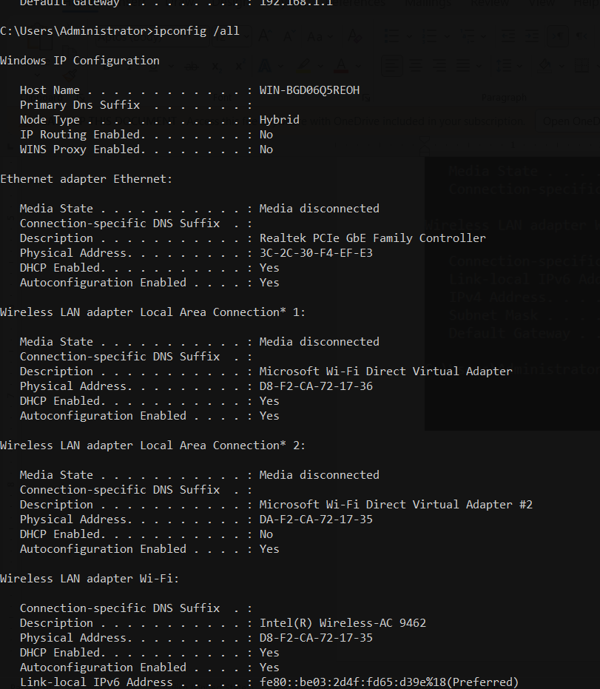
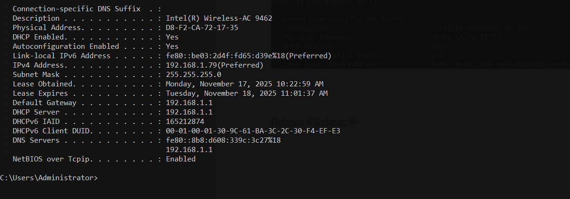
- How can you see your device’s MAC address?
  - Getmac
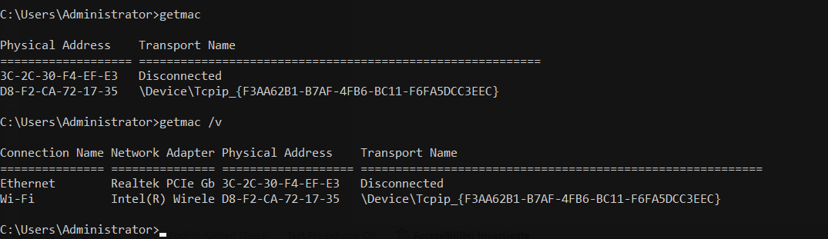
- How can you show the MAC address with more details?
  - getmac /v


APIPA & IP Configuration
- What is the default APIPA address when the device fails to get an IP from DHCP?
  - Starts with: 169.254.x.x
device success to get dhcp ip so apipa not exist
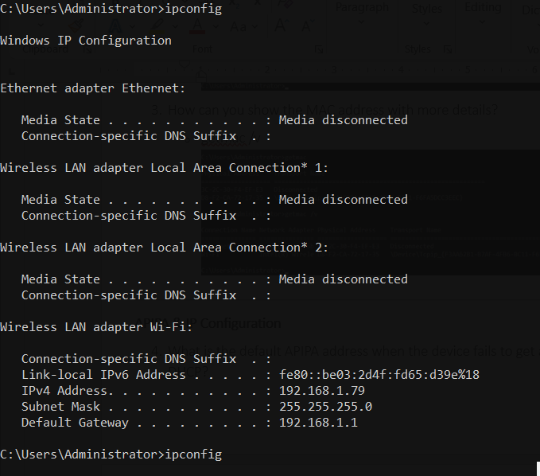
- What command shows your current IP settings?
  - Ipconfig
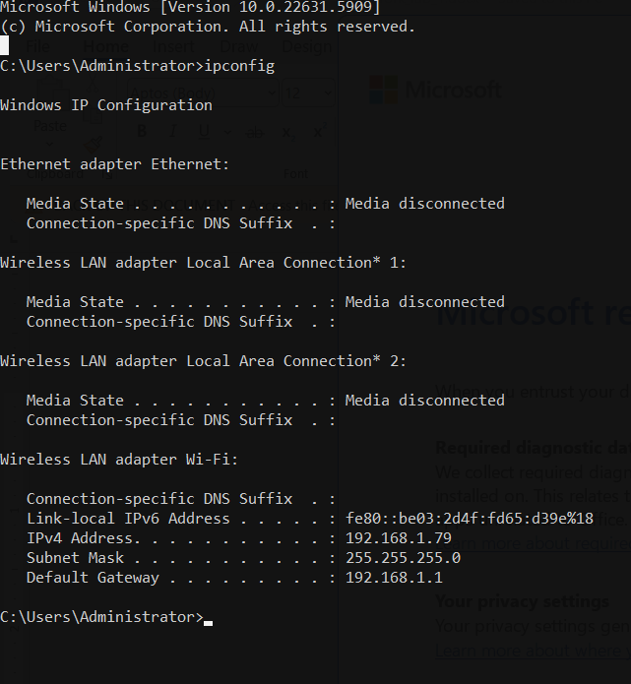
- How do you release your current IP address?
  - ipconfig /release
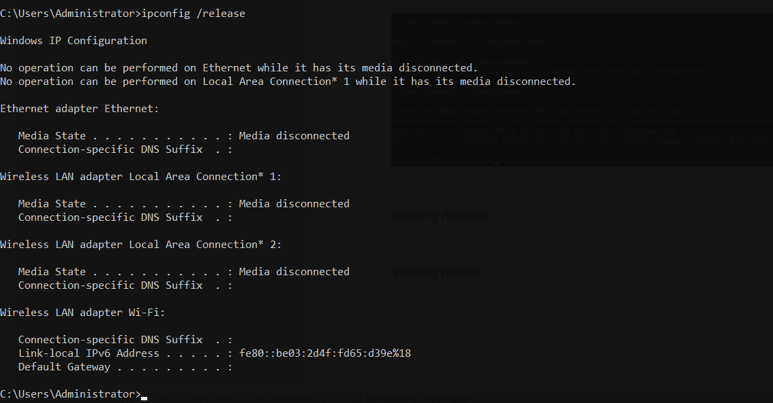
- How do you request a new IP address from DHCP?
  - ipconfig /renew
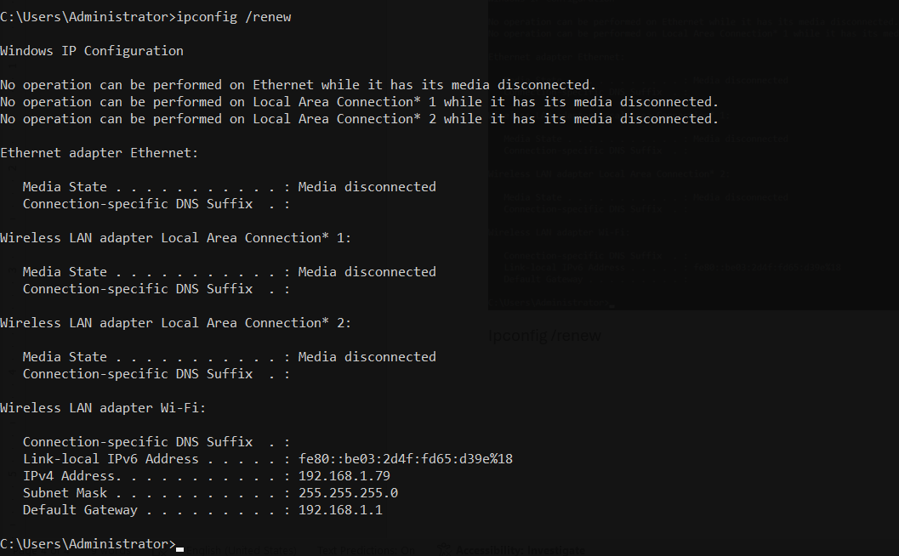

Ping Commands
- How do you test connection to an IP address?
  - ping [IP address]
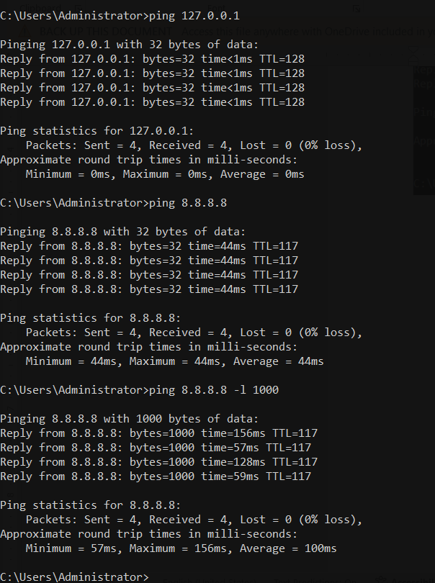
- How do you test connection to a website (URL)?
  - ping www.example.com
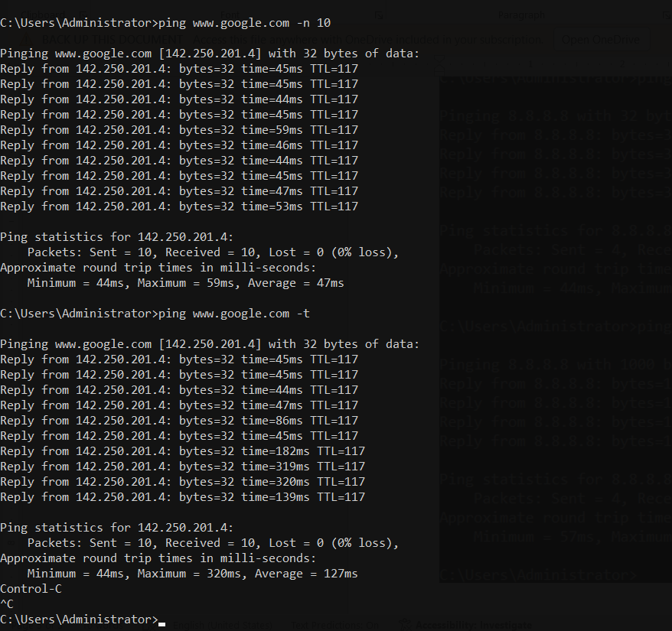
- How do you send a ping with a specific data size?
  - ping [IP] -l [size]

- How do you send a specific number of ping requests?
  - ping [IP] -n [count]

- How do you send continuous ping requests until you stop it manually?
  - ping [IP] -t


Netstat
- How do you show all active connections?
  - netstat -a
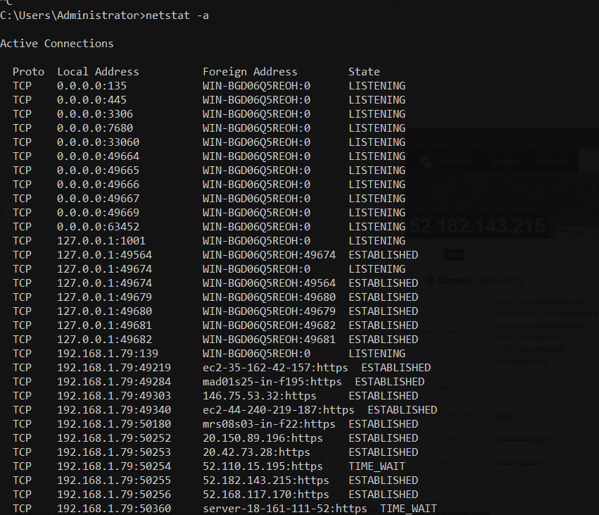
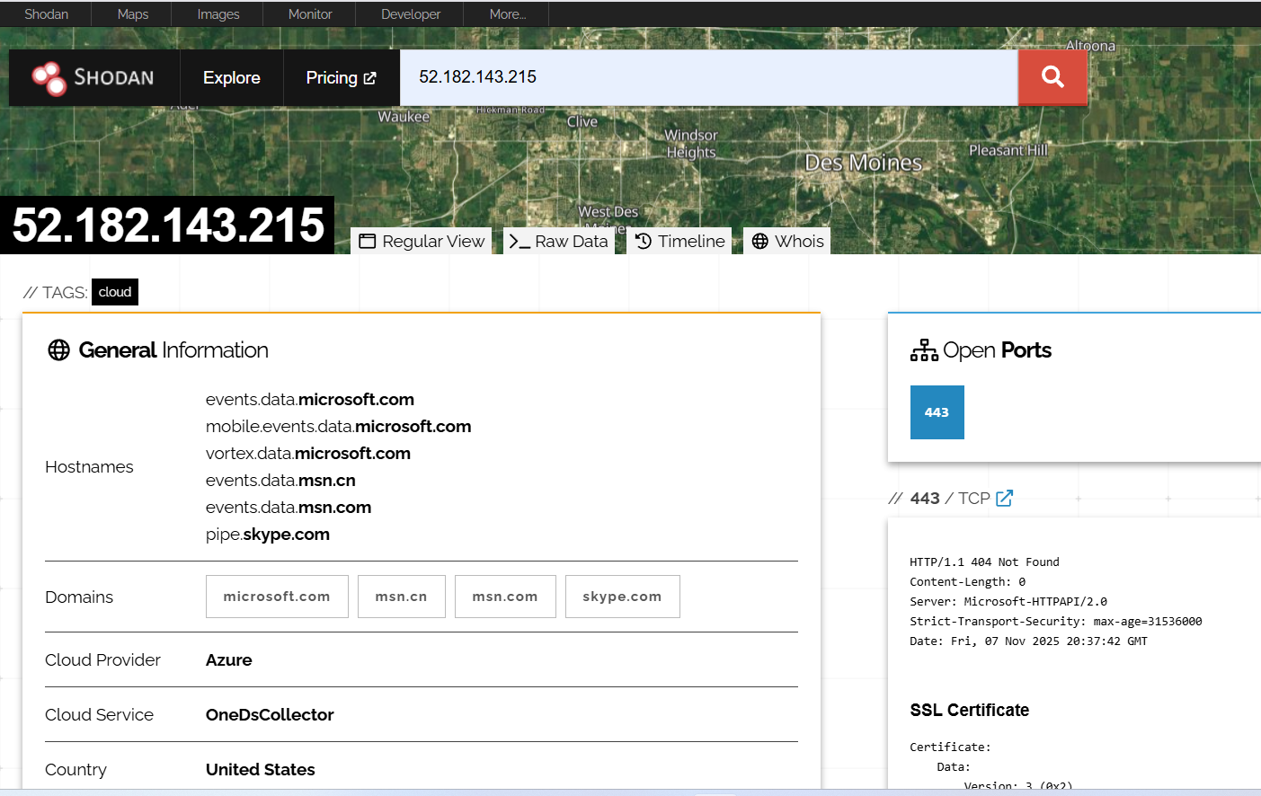
- How do you show active connections with numbers only?
  - netstat -n
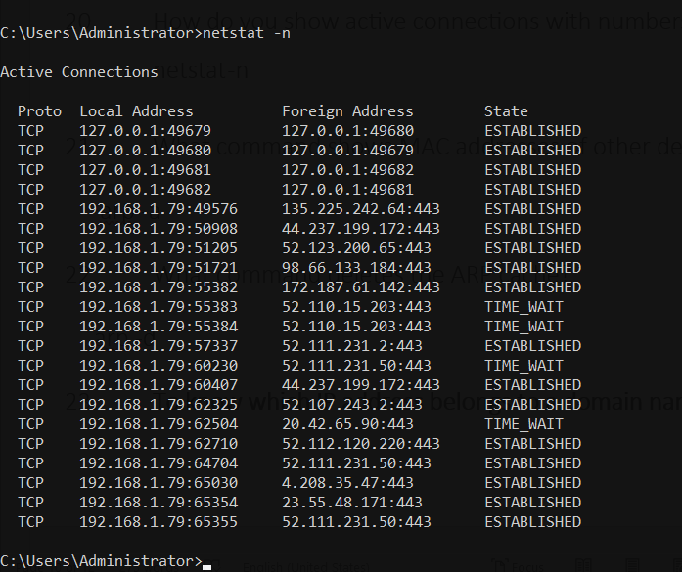
- What command shows MAC addresses of other devices on the network?
arp -a
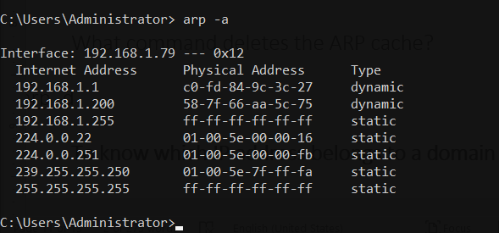
- What command deletes the ARP cache?
arp -d
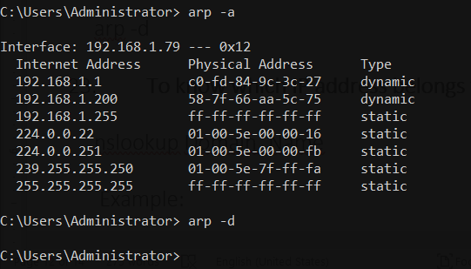
- To know which IP address belongs to a domain name:
nslookup Domain_Name
Example:
nslookup Yahoo.com
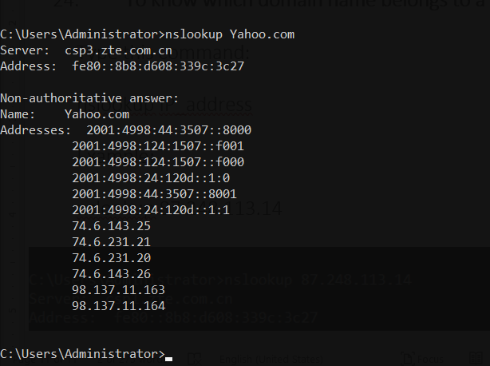
- To know which domain name belongs to a specific IP address:
Type this command:
nslookup IP_address
Example:
nslookup 87.248.113.14
